# LED driver

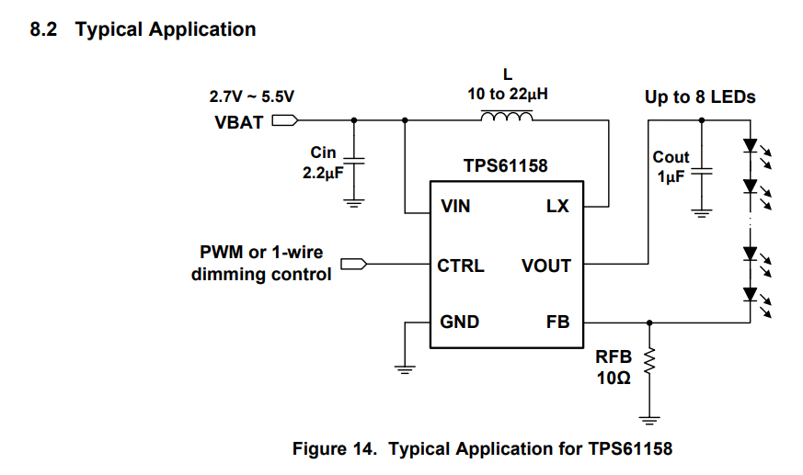

The input capacitor is to filter ripples from the power source and is there to function as a tiny buffer. The output capacitor is responsible for delivering current to the leds when the required current cannot be drawn continuously from the IC itself due to switching or power supply reasons. The inductor is there to function within the boost circuitry and has a high influence on the ripple and on maximum current and efficiency.

It is important to follow the pcb layout recommendations to avoid unsuspected behavior due to unwanted resistance or capacitances.

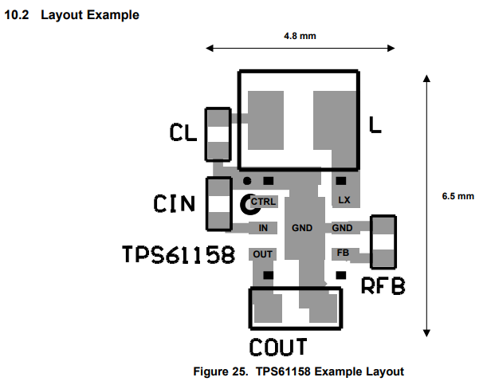

# Testing plan

When making a video or taking a picture of the reaction chamber, it is important that the LED light has a switching frequency that is higher than the shutter speed of the camera. If this is not the case, it could be that the image will appear to be darker or completely dark and that flickering will occur while recording a video. Therefor we need to know all shutter speeds of the camera and then we need to find what frequencies we need to drive the LED with, especially when dimming the light.

Our expected shutter speed: 60

Minimal shutter speed: 300usecs (<https://forums.raspberrypi.com/viewtopic.php?t=323983>)

Python control camera: <https://raspberrypi.stackexchange.com/questions/99304/shutter-speed-and-exposure-time-of-picamera>

About shutter speed and fps: <https://camerajabber.com/what-shutter-speed-for-filming-moving-subjects/#:~:text=The%20180%2Ddegree%20Shutter%20Rule%20states%20that%20whatever%20the%20framerate,What%20is%20this%3F&text=Therefore%20if%20you%27re%20shooting,speed%20should%20be%201%2F120th>.

## Driver circuit decision table

|  |  |  |  |  |  |  |  |  |  |
| --- | --- | --- | --- | --- | --- | --- | --- | --- | --- |
| **Nr.** | **Functionality** | **1** | **2** | **3** | **4** | **5** | **6** | **Points** | **Weightfactor** |
| **1** | **Dim the led without visible flickering** | - | 1 | 1 | 1 | 1 | 1 | 5 | 5 |
| **2** | **Provide enough power to fully brighten LED** | 0 | - | 0 | 1 | 1 | 1 | 3 | 3 |
| **3** | **Enough brightness levels** | 0 | 1 | - | 1 | 1 | 0 | 3 | 3 |
| **4** | **PWM and digital control** | 0 | 0 | 0 | - | 0 | 1 | 1 | 1 |
| **5** | **PWM only control** | 0 | 0 | 0 | 1 | - | 1 | 2 | 2 |
| **6** | **Highest energy efficiency as possible** | 0 | 0 | 0 | 0 | 0 | - | 0 | 0 |